:Emmett Swivel
Counterstool
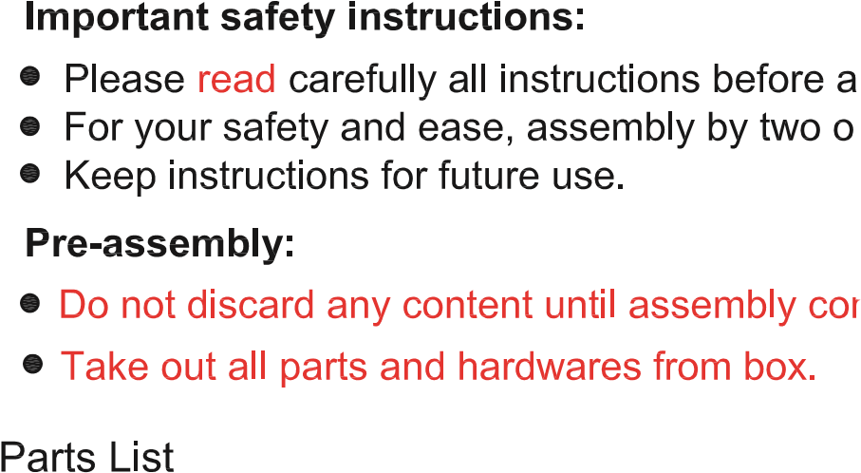 |  |  |  |  | 
P1 |  |  | CHAIR SEAT |  | 1PC
P2 |  |  | SWIVEL |  | 1PC
P3 |  |  | CROSSING SEAT |  | 1PC
P4 |  |  | LEGS |  | 4PCS
P5 |  |  | FOOTREST |  | 4PCS
H1 | BOLTS DIA:5/16"x2-3/8" |  |  |  | 8PCS
H2 | LOCK WASHER |  |  |  | 8PCS
H3 | FLAT WASHER |  |  |  | 8PCS
H4 | BOLTS DIA:1/4"x9/16" |  |  |  | 4PCS
H5 | BOLTS DIA:1/4"x1" |  |  |  | 4PCS
H6 | FLAT WASHER |  |  |  | 8PCS
H7 | SCREW |  |  |  | 8PCS
H8 | ALLEN WRENCH 1/4" |  |  |  | 1PC
H9 | SCREWDRIVER |  |  |  | Not Provided

Step 1. Assemble the chair on a flat, soft surface such as a carpet or cloth prevent scratching the finish. Insert legs(P4) to the crossing seat frame(P3), lock the legs to the seat frame using allen wrench (H8)to loosely tighten bolts (H1),lock washers(H2),flat washers(H3) as illustration below.
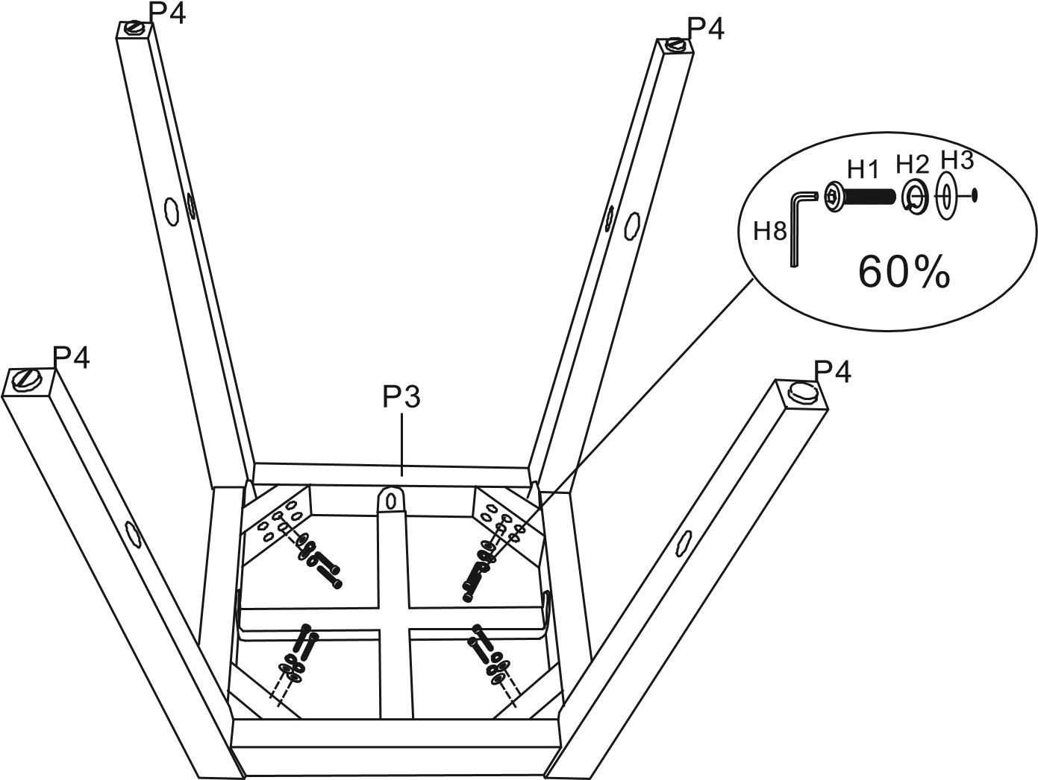
Step 2. Insert footrest(P5) to the legs(P4),lock the footrest to the legs with screws(H7) and tighten all screws securely with screw driver(H9) as illustration below.
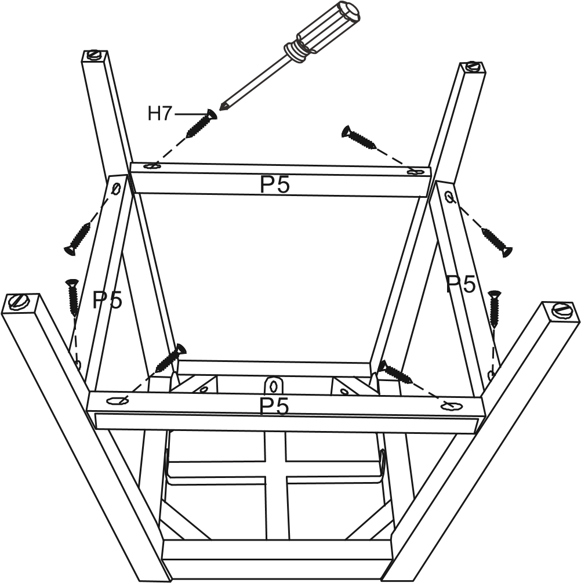

Step 3. Turn the whole leg frame, upright on the surface tighten all bolts securely with allen wrench.
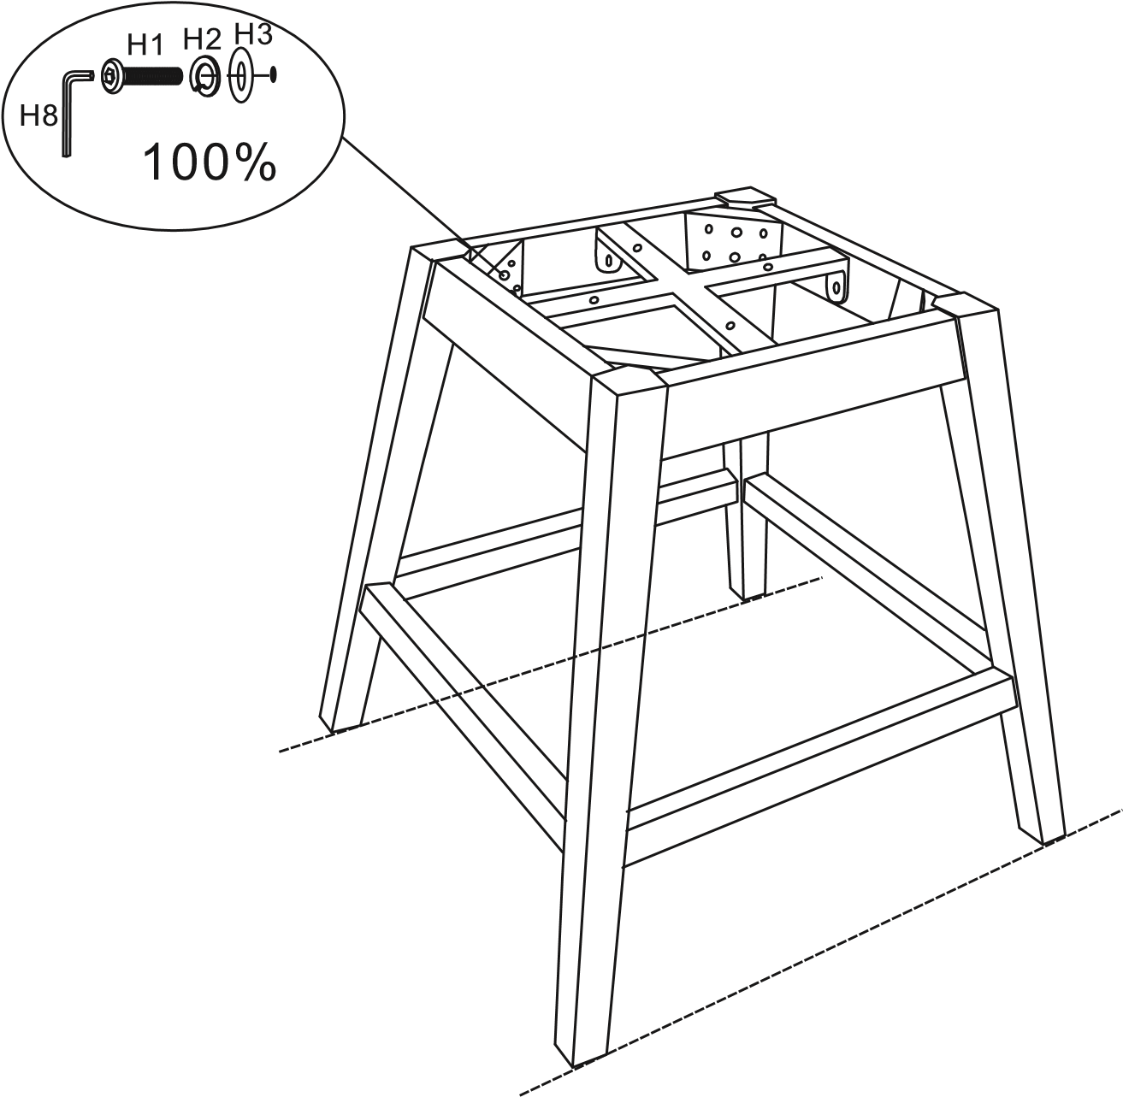
Step 4. Attach the swivel(P2) to the leg frame with bolts(H4) and flat washes(H6), tighten all bolts securely with allen wrench(H8) .
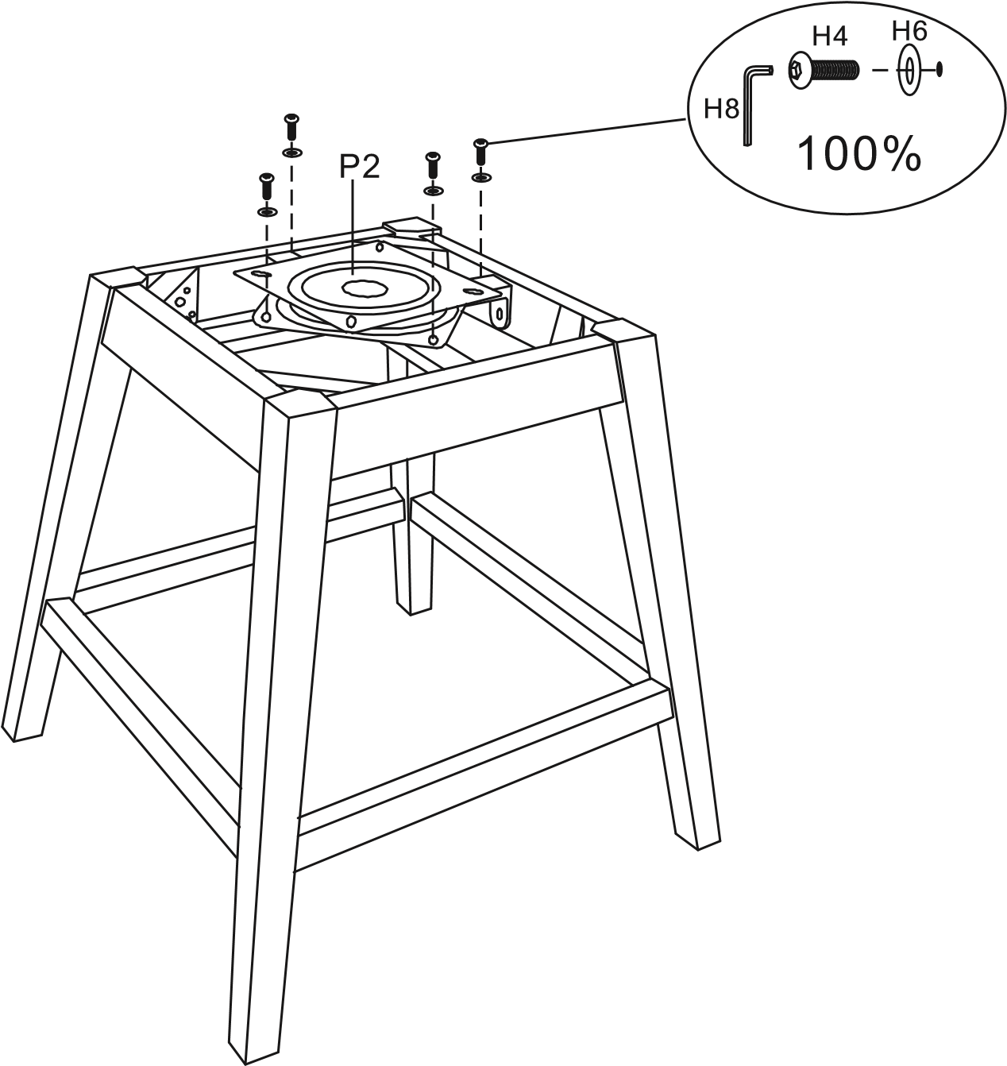

Step 5. Attach the swivel(P2) to chair seat(P1) with bolts(H5),flat washes(H6) and tighten all bolts securely with allen wrench(H8) .
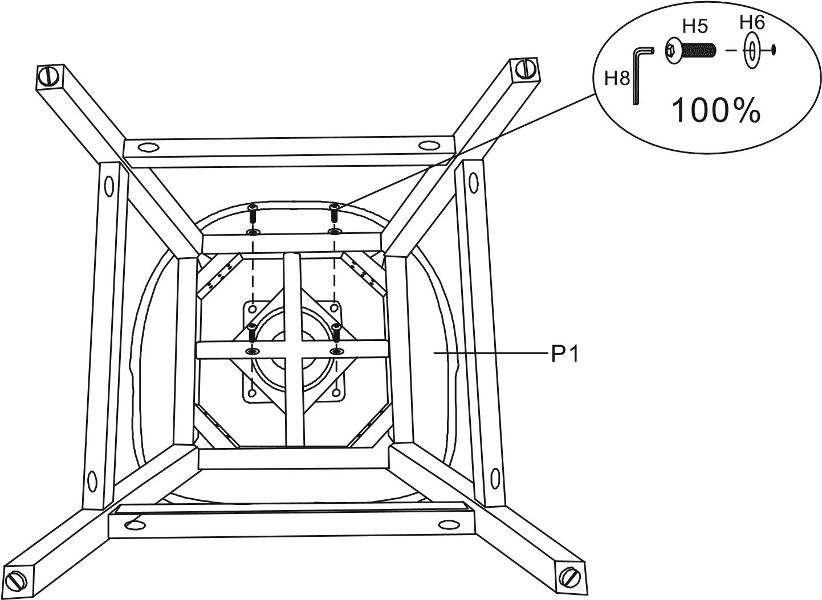
Step 6. Turn chair upright on a level surface. Adjust levelers (as drawing) as necessary.
