ISTA 3A drop test
Customer | MP | Tested by | Simon
Vendor | XN | Report Author | Simon
Test Date | 2020-11-11 | Test Result | PASS

Item# | Package Size | Length + Girth | Product size(in.) | G.W. (KG) | N.W.(KG)
MP100-0575 | 32”X32”X26.75”H | 149.5” | 30*30.5*30.25" H | 27 kg | 19.5 kg
Description | Brayden Accent Chair

Test Specimen Picture | Test Result Summary
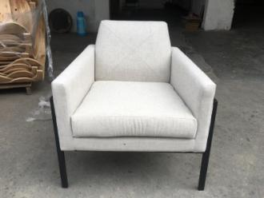 | 包装方式按3A标准试摔， 测试通过

Packaging picture | Product Picture
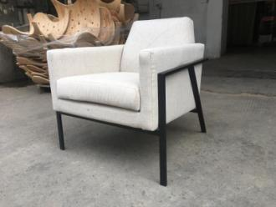 | 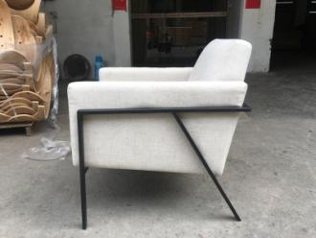
Failure details
N/A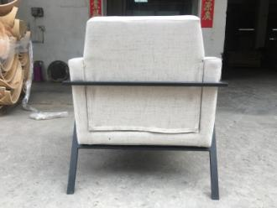 | N/A
Suggested Corrective Actions
N/ | N/A

Description of Packaging
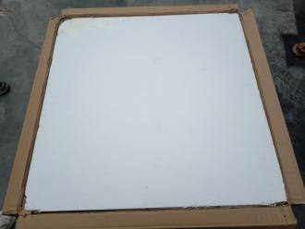 | 保丽龙： 16KG 800 X 800 X 20MM 2PCS面底
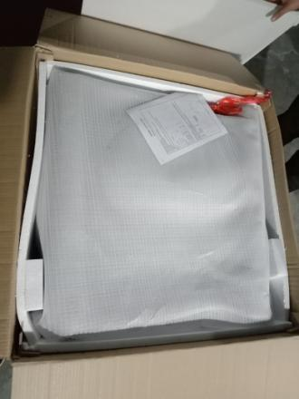 | 保丽龙 16kg，780 X 612 X 20 MM , 4PCS  保丽龙 12kg，620 X 120 X 40 MM , 2PCS
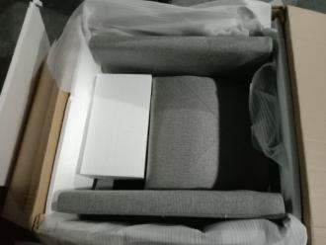 | 保丽龙 12kg，450 X 250 X 155 MM , 1PCS
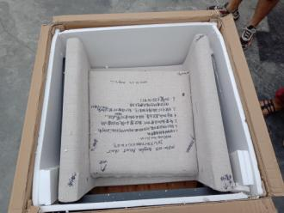
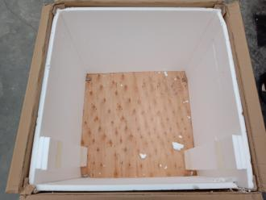 | 保护板 800 X 800 X 5 MM 1PCS 夹板  100 X 100 X 5 MM 4PCS 打胶打钉固定在整板四角
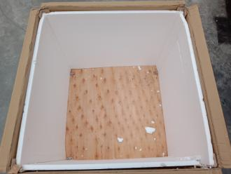
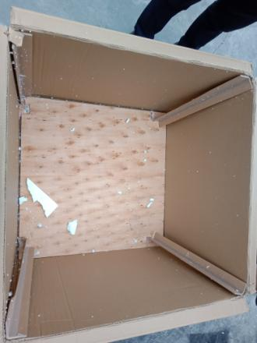 | 硬纸护边 630 X 50 X 50 X 5 MM 4PCS
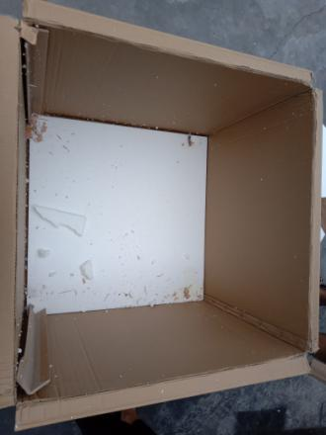
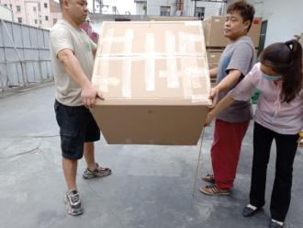 | 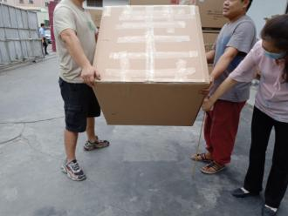
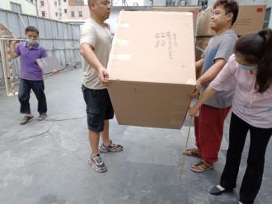 | 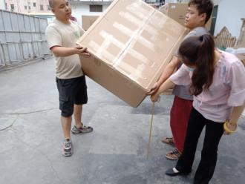
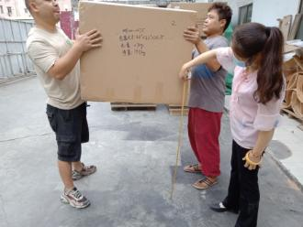 | 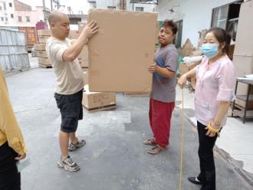
Drop Test Sequence
Drop No.  (1st seq.) | Drop Height (inch) |  |  |  | Test Specimen |  | Drop No.  (2nd seq.) | Drop Height (inch) |  |  |  | Test Specimen
Drop No.  (1st seq.) | <32kg  (70lbs) |  | 32-70kg  (70-150lbs) |  | Standard, Flat, Elongated |  | Drop No.  (2nd seq.) | <32kg  (70lbs) |  | 32-70kg  (70-150lbs) |  | Standard, Flat, Elongated
1 | 18 |  | 12 |  | Edge 3-4 |  | 10 | 18 |  | 12 |  | Edge 3-4
2 | 18 |  | 12 |  | Edge 3-6 |  | 11 | 18 |  | 12 |  | Edge 3-6
3 | 18 |  | 12 |  | Edge 4-6 |  | 12 | 18 |  | 12 |  | Edge 1-5
4 | 18 |  | 12 |  | Corner 3-4-6 |  | 13 | 18 |  | 12 |  | Corner 3-4-6
5 | 18 |  | 12 |  | Corner 2-3-5 |  | 14 | 18 |  | 12 |  | Corner 1-2-6
6 | 18 |  | 12 |  | Edge 2-3 |  | 15 | 18 |  | 12 |  | Corner 1-4-5
7 | 18 |  | 12 |  | Edge 1-2 |  | 16 | 36 |  | 24 |  | Most critical or damage-prone flat orientation
8 | 36 |  | 24 |  | Face 3 |  | 17 | 18 |  | 12 |  | Standard: Face 3 on hazard  Flat or Elongated: Face 2 on hazard
9 | 18 |  | 12 |  | Face 3
Additional drop/impact tests
Flat |  |  |  |  |  |  | Elongated
Rotation Edge Drop |  |  |  |  |  |  | Rotation Edge Drop
Height (in.) |  | Specific edge |  |  |  |  | Height (in.) |  | Specific edge
Support height: 4 in  Drop height: 8 in |  | 1. One of the longest face 3 edges |  |  |  |  | Support height: 4 in  Drop height: 8 in |  | 1. One of the longest face 3 edges
 |  | 2. Next longest edge radiating 90° from the edge just tested |  |  |  |  |  |  | 2. Next longest edge radiating 90° from the edge just tested
 |  | 3. The opposite edge tested in Sequence 2 |  |  |  |  |  |  | 3. The opposite edge tested in Sequence 2
Full Rotational Flat Drop |  |  |  |  |  |  | Full Rotational Flat Drop
Rest on a rigid surface |  |  |  | Impact face |  |  | Rest on a rigid surface |  |  |  | Impact face
Smallest face |  |  |  | Face 3 |  |  | Smallest face |  |  |  | Face 3
Nest largest face |  |  |  | Face 3 |  |  | Nest largest face |  |  |  | Face 3
Concentrated Impact |  |  |  |  |  |  | Bridge Impact
Drop height (in) |  |  |  | 16 in |  |  | Drop height (in) |  |  |  | 16 in

