
ASSEMBLY INSTRUCTIONS

Barrow Pandent (Item#: MT151-0017)
Important Safety Instructions:
- We recommend you contact a professional electrician to install any hardwired lighting. Incorrect installation can lead to fires.
- These instructions are provided for your safety. It is very important that they are read carefully and completely before assembling fixture..
- This fixture has been rated for up to (6) 25-watt maximum TYPE B bulbs (not included) or (6) 9-watt compact fluorescent light bulbs (not included) or (6) 4-watt standard base LED bulbs (not included). To avoid the risk of fire, do not exceed the recommended wattage.

Pre-assembly:
- Do not discard any contents until after assembly is complete to avoid accidentally discarding small parts or hardware.
- Remove all parts and hardware from box along with any plastic protective packaging.

Parts Enclosed: Hardware Included:
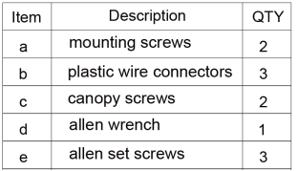
Item | Description | QTY
A | Mounting Plate | 1
B | Canopy | 1
C | Tube | 1
D | Lamp Body | 1
E | Arm | 3

To install you will need: Screw driver/Electrical tape

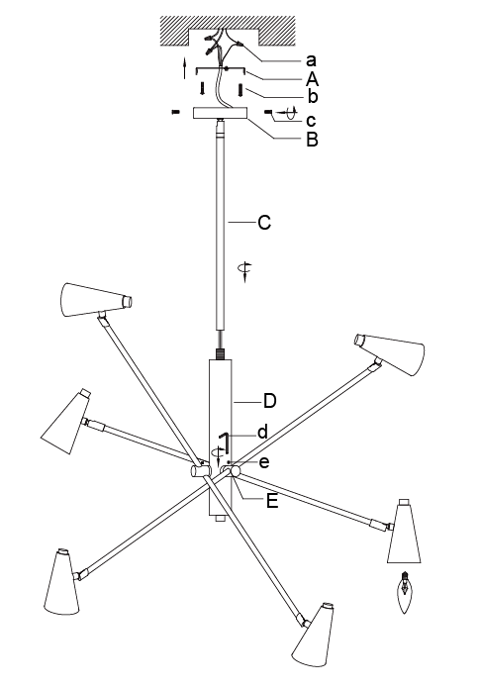

Care instructions:
• Wipe with soft dry cloth only
• Always avoid the use of harsh chemicals or abrasive as they may damage to the finish.

Thank you for your purchase

