
ASSEMBLY INSTRUCTIONS

Inwood Chandelier (Item#: MT150-0041)
Important Safety Instructions:
- We recommend you contact a professional electrician to install any hardwired lighting. Incorrect installation can lead to fires.
- These instructions are provided for your safety. It is very important that they are read carefully and completely before assembling fixture..
- This fixture has been rated for up to (6) 25-watt maximum TYPE B bulbs (not included) or (6) 9-watt compact fluorescent light bulbs (not included) or (6) 4-watt standard base LED bulbs (not included). To avoid the risk of fire, do not exceed the recommended wattage.

Pre-assembly:
- Do not discard any contents until after assembly is complete to avoid accidentally discarding small parts or hardware.
- Remove all parts and hardware from box along with any plastic protective packaging.

Parts Enclosed: Hardware Included:
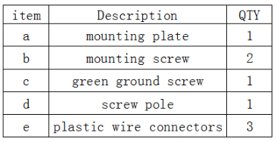
Item | Description | QTY
A | Canopy | 1
B | Loop Ring | 1
C | Loop | 1
D | Chain | 1
E | Big Loop | 1
F | Tube | 1
G | Lamp Body | 1
H | Shade | 6
I | Socket Ring | 6

To install you will need: Screw driver/Electrical tape

To Adjust the Suspension Length of the Fixture:
- The adjustment or shortening of the lighting fixture’s suspension length is only needed if the factory set length is not appropriate for your installation. We recommend that you adjust the lighting fixture to the proper desired length before cutting the electrical cord.
- Determine the lighting fixture suspension length from the ceiling for the product installation, allowing the extra cord length for the outlet junction box wire connections. If needed, cut off the extra power cord length on the 3 wire cords so that they all at least 6 inches (152.4mm) long within the outlet junction box.(J-box)
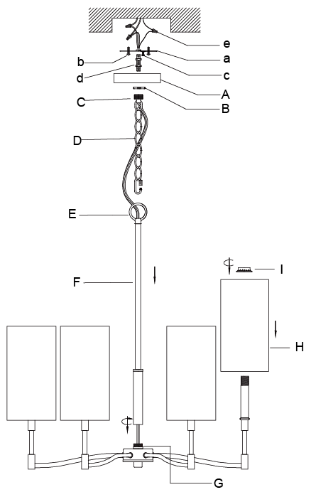

Care instructions:
• Wipe with soft dry cloth only
• Always avoid the use of harsh chemicals or abrasive as they may damage to the finish.

Thank you for your purchase

