
ASSEMBLY INSTRUCTIONS

Holloway Floor Lamp (Item#: MPS154-0102)

Important Safety Instructions:
- For safety purpose, this lamp is equipped with a polarized plug (one blade is wider than the other). If the plug does not fit securely into your outlet, do not force it, contact a professional electrician. Never alter the plug in any way.
- These instructions are provided for your safety. It is very important that they are read carefully and completely before assembling fixture.
- This fixture has been rated for up to (3) 9.5-watt LED maximum TYPE A bulb .To avoid the risk of fire, do not exceed the recommended wattage.

Pre-assembly:
- Do not discard any contents until after assembly is complete to avoid accidentally discarding small parts or hardware.
- Remove all parts and hardware from box along with any plastic protective packaging.
Parts Enclosed:
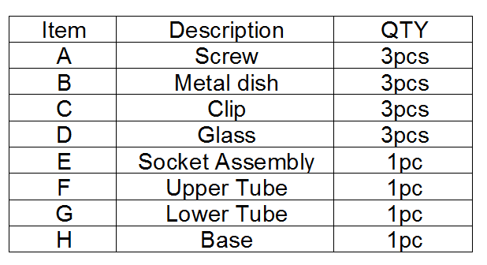

Warning:
- Wires and cables are all attached (further wiring is not needed from consumer). When unpacking product, be careful to not pull wires as it may result as a bad connection. Do not plug into electrical outlet until lamp is fully assembled.

Note:

Turn the power off (unplug from the wall outlet) before replacing the bulb. Make sure the bulb has sufficient time to cool down.

Assembly Instruction:

Step1. Unpack and place all parts on a surface or floor.
Step2. Put Lamp Base (H) on a Flat surface.
Step3. Screw Lower Tube (G) onto Lamp Base (H).
Step4. Screw Upper Tube (F) onto Lower Tube (G)
Step4. Screw Socket Assemble (E) onto Tube (F) ,Be careful not to twist the power cord, tighten securely.
Step5. Screw light bulb (not included) into the Socket.
Step6. Put the Glass Shade (D) onto Clip (C) and use Screw (A) to screw Metal dish(B) and Glass Shade (D).
Make sure the Glass shade is screwed and fixed on Clip (B) tightly.
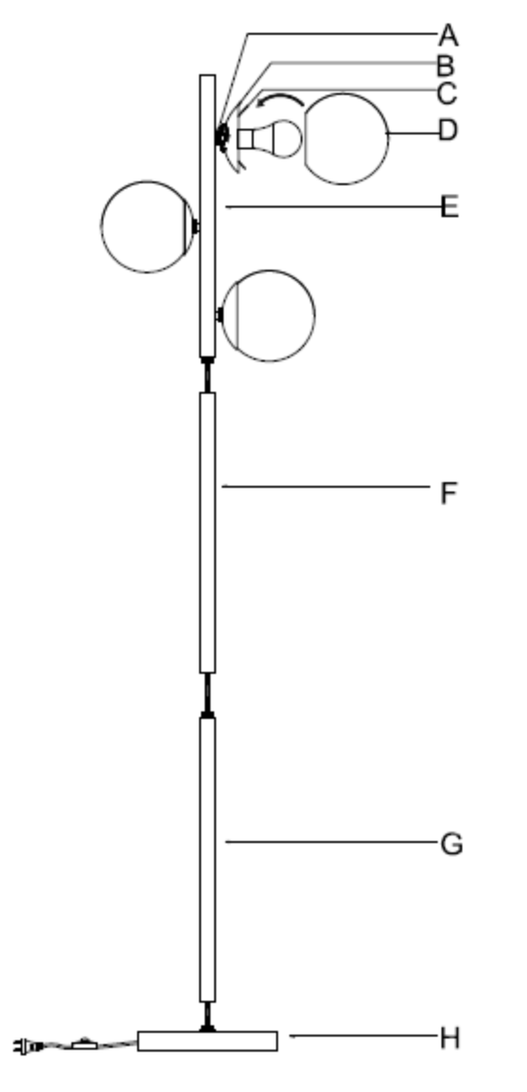
Step7.Assembly is completed.

Care instructions:
• Wipe with soft dry cloth only
• Always avoid the use of harsh chemicals or abrasive as they may damage to the finish.

Thank you for your purchase

