
ASSEMBLY INSTRUCTIONS
Amma Pendant (Item#: MPS151-0106)
Important Safety Instructions:
- For safety purpose, this lamp is equipped with a polarized plug (one blade is wider than the other). If the plug does not fit securely into your outlet, do not force it, contact a professional electrician. Never alter the plug in any way.
- These instructions are provided for your safety. It is very important that they are read carefully and completely before assembling fixture.
- This fixture has been rated for up to (5) 40-watt maximum TYPE A bulbs or (5) 7-watt compact fluorescent light bulbs..To avoid the risk of fire, do not exceed the recommended wattage.

Pre-assembly:
- Do not discard any contents until after assembly is complete to avoid accidentally discarding small parts or hardware.
- Remove all parts and hardware from box along with any plastic protective packaging.

Parts Enclosed: Hardwire Parts
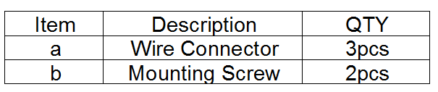
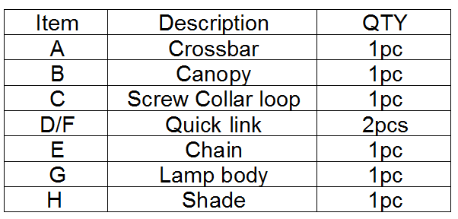

Warning:
- Wires and cables are all attached (further wiring is not needed from consumer). When unpacking product, be careful to not pull wires as it may result as a bad connection. Do not plug into electrical outlet until lamp is fully assembled.

Note:

Turn the power off (unplug from the wall outlet) before replacing the bulb. Make sure the bulb has sufficient time to cool down.

.
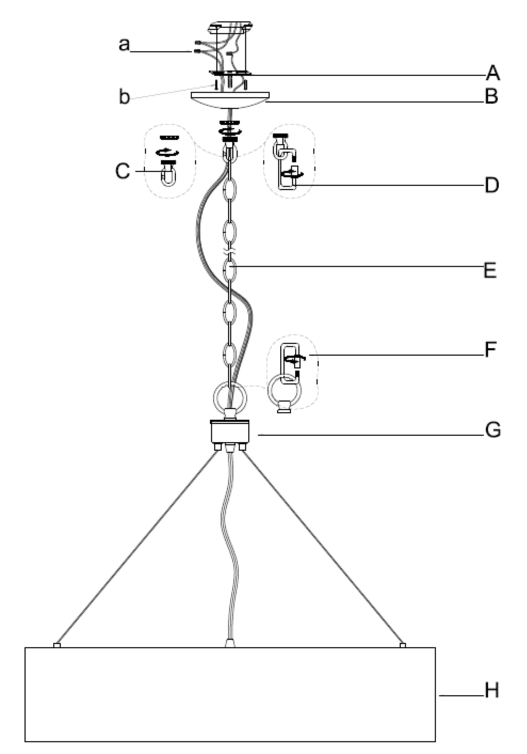

Care instructions:
• Wipe with soft dry cloth only
• Always avoid the use of harsh chemicals or abrasive as they may damage to the finish.

Thank you for your purchase

