ASSEMBLY INSTRUCTIONS

Beckton Pendant (item#MPS151-0094)
Important Safety Instructions:
- We recommend you contact a professional electrician to install any hardwired lighting. Incorrect installation can lead to fires.
- These instructions are provided for your safety. It is very important that they are read carefully and completely before assembling fixture.
- This fixture has been rated for up to 60-watt maximum TYPE A bulbs or13-watt compact fluorescent light bulbs. To avoid the risk of fire, do not exceed the recommended wattage.

Pre-assembly:
- Do not discard any contents until after assembly is complete to avoid accidentally discarding small parts or hardware.
- Remove all parts and hardware from box along with any plastic protective packaging.

Parts Enclosed:

Item | Description | QTY
A | Plastic wire connectors | 3
B | bolts | 2
C | Mounting screws | 2
D | canopy | 1
E | flying rings | 1
F | bulb | 1
G | Glass tube | 30

To install you will need: Screwdriver/Electrical tape

Assembly Notes:

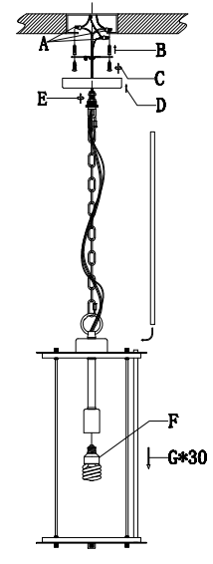
Note:
Need to insert the bulb first and then assembly the glass tube. when change the bulb you need to pull out 5 pcs glass tube .

Care instructions:
• Wipe with soft dry cloth only
• Always avoid the use of harsh chemicals or abrasive as they may damage to the finish.
Thank you for your purchase

