 ASSEMBLY INSTRUCTIONS

Lunar Pendant (Item# MP151-0124)
Important Safety Instructions:
- We recommend you contact a professional electrician to install any hardwired lighting. Incorrect installation can lead to fires.
- These instructions are provided for your safety. It is very important that they are read carefully and completely before assembling fixture.
- This fixture has been rated for up to (1) 60-watt maximum TYPE A bulb (not included) or (1) 13-watt compact fluorescent light bulb (not included). To avoid the risk of fire, do not exceed the recommended wattage.

Pre-assembly:
- Do not discard any contents until after assembly is complete to avoid accidentally discarding small parts or hardware.
- Remove all parts and hardware from box along with any plastic protective packaging.

Parts Enclosed: Hardware Included:

Item | Description | QTY |  | Item | Description | QTY
A | Mounting plate | 1 |  | a | Mounting screw | 2
B | Canopy | 1 |  | b | Wire nut | 3
C | Threaded pipe | 1 |  | c | Fixed ring | 1
D | Canopy ring | 1 |  | d | Chain | 2
E | Sling chain | 1 |  | e | Rings | 1
F | Glass lampshade | 1 |  | f | Bulb (not include)

To install you will need: Screwdriver/Electrical tape
To Adjust the Suspension Length of the Fixture:
      - The adjustment or shortening of the lighting fixture’s suspension length is only needed if the factory set Sling chain (E) length is not appropriate for your installation. We recommend that you adjust the sling chain (E) to the desired length.
      - Determine the lighting fixture suspension length from the ceiling for the product installation, allowing the extra cord length for the outlet junction box wire connections as noted below.
      - If you need to remove the mounting plate (A) from the canopy (B) by rotating the fixing rings (c). Do not throw away the fixed ring (c), because these will be used later.
      - Threaded pipe (C) and Canopy ring (D) clockwise screw Fixed ring (c) Canopy ring screw clockwise (D) Canopy (B). Do not over tighten the Fixed ring (c), Canopy (B) to ensure that the sliding not with pendant downward.
      - If needed, cut off the extra power cord length on the 3 wire cords so that they all are at least 6 inches (152.4 mm) long within the outlet junction box (J-box).

Green ground screw
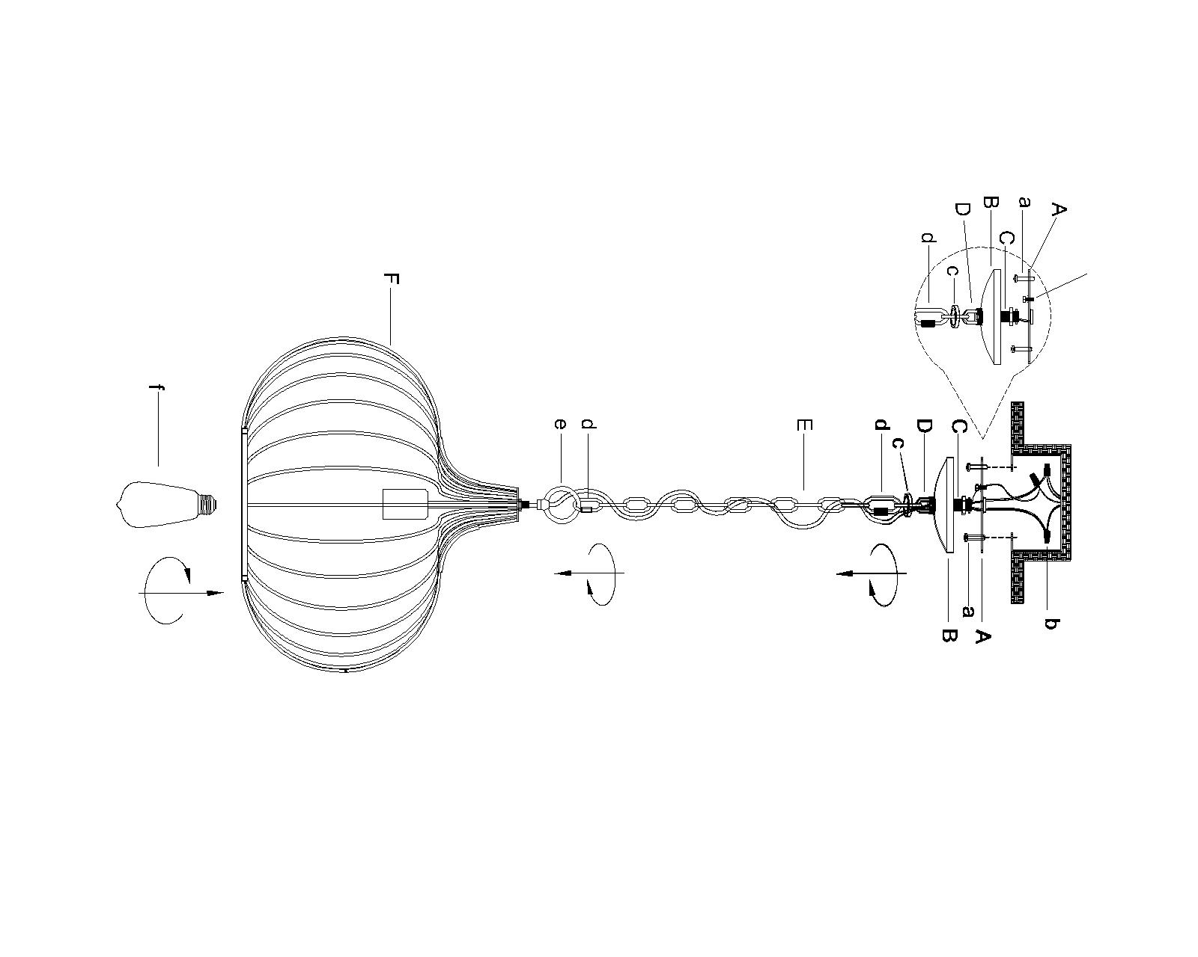

Care instructions:
• Wipe with soft dry cloth only
• Always avoid the use of harsh chemicals or abrasive as they may damage to the finish.
Thank you for your purchase

