
ASSEMBLY INSTRUCTIONS

Morton Metal Pendant Light (Item# II151-0093)
Important Safety Instructions:
- We recommend you contact a professional electrician to install any hardwired lighting. Incorrect installation can lead to fires.
- These instructions are provided for your safety. It is very important that they are read carefully and completely before assembling fixture.
- This fixture has been rated for up to (1) 60-watt maximum TYPE A bulb or (1) 13-watt compact fluorescent light bulb. To avoid the risk of fire, do not exceed the recommended wattage.

Pre-assembly:
- Do not discard any contents until after assembly is complete to avoid accidentally discarding small parts or hardware.
- Remove all parts and hardware from box along with any plastic protective packaging.

Parts Enclosed: Hardware Included:
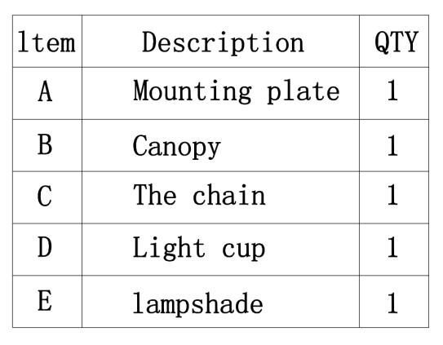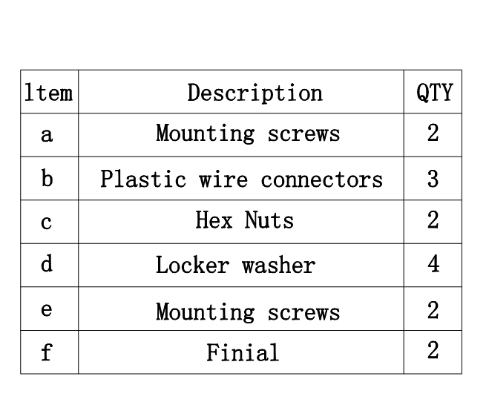
To install you will need: Screwdriver/Electrical tape
To Adjust the Suspension Length of the Fixture:
      - The adjustment or shortening of the lighting fixture’s suspension length is only needed if the factory set the Cord (D) length is not appropriate for your installation. We recommend that you adjust the Cord (D) to the proper desired length before cutting the electrical cord.
      - Determine the lighting fixture suspension length from the ceiling for the product installation, allowing the extra cord length for the outlet junction box wire connections as noted below.
      - If need, separate the Mounting plate (A) from the Canopy (B) by removing the 2 Canopy Screws (c). Do not discard the Canopy Screws (c) as these will be used later.
      - Loosen the Allen Screw (d) from the Cord Collar (C) using the Allen Wrench (e) by turning the wrench in a counter-clockwise.
      - Insert the Cord (D) upwards through the Canopy (B) until a new desired suspension length is determined.
      - Secure the Cord (D) in place by turning the Allen Screw (d) in a clockwise direction using the Allen Wrench (e) until tight. Do not over tighten the screw, making sure the Cord (D) cord will not slip downwards with the pendant body.
      - If needed, cut off the extra power cord length on the 3 wire cords so that they all are at least 6 inches (152.4 mm) long within the outlet junction box (J-box).

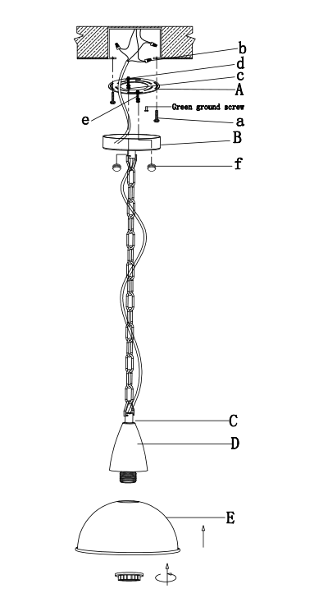

Care instructions:
• Wipe with soft dry cloth only
• Always avoid the use of harsh chemicals or abrasive as they may damage to the finish.
Thank you for your purchase

