

ASSEMBLY INSTRUCTIONS
Calista Chandelier with 8 Clear Glass Lights (Item# II150-0153)
Caution:
- FOR YOUR SAFETY: Turn off the power to main electric circuit/ fuse box before beginning work.

Important Safety Instructions:
- Professional installation is recommended for hardwired lighting. Incorrect installation can lead to fires.
- These instructions are provided for your safety. It is very important that they are read carefully and completely before assembling fixture.
- We strongly recommend that two people install the lighting fixture.
- This fixture has been rated for up to (8) 40-watt maximum TYPE B bulbs (not included) or (8) 4W LED light bulbs (not included). To avoid the risk of fire, do not exceed the recommended wattage.
- This lighting fixture is intended for indoor, residential use.

Warning:
- To reduce the risk of fire, electrical shock or personal injury, do not turn on lighting fixture until light bulb is installed and assembly is complete.
- Always turn off the lighting fixture and allow it to cool before replacing the light bulb.

Care Instructions:
- Do not polish or use harsh cleaners as they may damage the finish.
- Wipe clean with a non-colored, lint-free soft, dry cloth.

Pre-assembly:
- Remove all parts and hardware from box along with any plastic protective packaging.
- Check that all parts listed are included.
- Do not discard any contents until after assembly is complete to avoid accidentally discarding small parts or hardware.

Component List
Part Code | Components | Description | Qty
A | 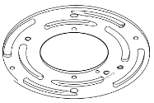 | Mounting Plate | 1
B | 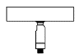 | Canopy with Swivel Head | 1
C | 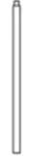 | 6” Short Tube | 1
D |  | 12” Long Tubes | 2
E | 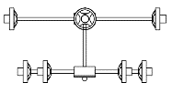 | Lamp Body | 1
F | 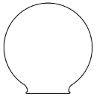 | Glass Shades | 8

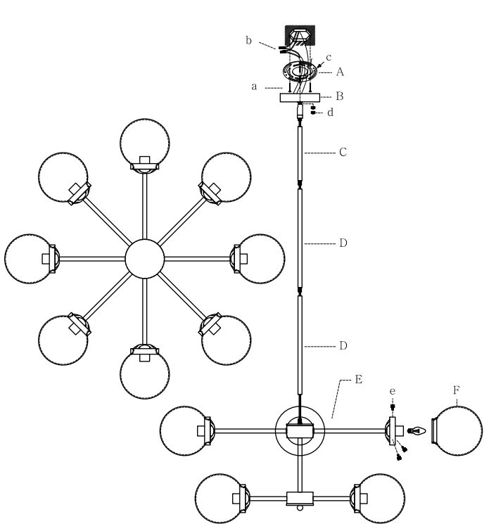

Part code | Components | Description | Qty
a | 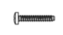 | Grub Screws | 2
b | 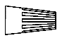 | Wire nuts | 3
c | 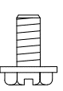 | Ground Screw | 1
d | 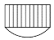 | Screw Caps | 2
e | 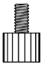 | Screws | 24

Assembly Instruction:

Step 1. Unpack and place all parts on a surface or floor.

Step 2. Attach the mounting plate (A) to the outlet box with grub screws (a) and ground screw (c); Connect the wires with wire nuts (b).

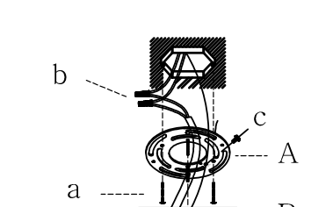

Step 3. The fixture includes one 6” short tube (C) and two 12” long tubes (D). Customize your desired hanging height by using tubes (C) and (D), then thread the fixture wires through the chosen tubes. Securely attach the tubes (C) and (D) onto the fixture body (E) by gently screwing them in place.
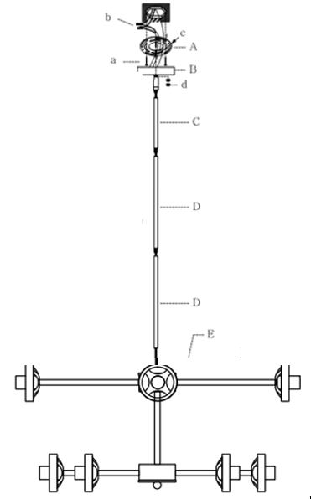

Step 4. Place the canopy (B) onto the tube (C) and securely fasten it by screwing it tight.
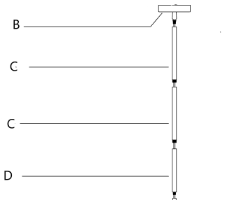

Step 5: Complete the wire connections with the assistance of another person supporting the fixture's weight. Connect the fixture's wires to the power supply wires from the junction box, ensuring a matching scheme: black to black (Live), white to white (grounded), and grounding to grounding (green or copper). Twist the ends of the wire pairs together uniformly, and then secure them with a wire connector, ensuring consistent twisting direction. Loop the fixture's ground wire around the grounding screw and tighten it. If there's no ground wire (green or copper) from the junction box, seek assistance from a qualified electrician.

Step 6: Elevate the canopy (B) to the ceiling with assistance to support the lighting fixture's weight, and firmly affix it by connecting the canopy (B) to the mounting plate (A) using the Screw caps (d).
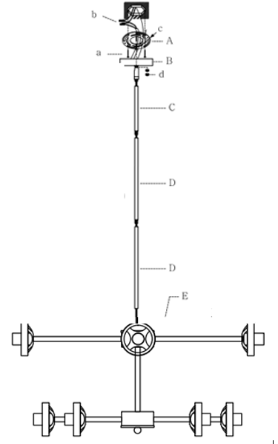
Step 7: Insert the bulbs (not included) into the sockets, then delicately place the shade (F) onto the socket and secure it using three screws (e). Please do not exceed the maximum wattage recommended on the socket. Repeat this process for the rest of the lights.

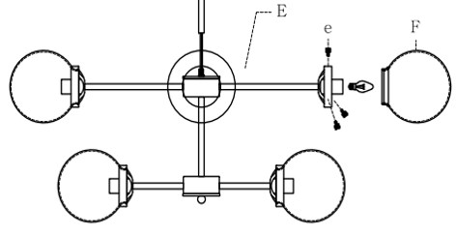

Step 8. Check everything is installed properly, then you can turn on the light. Enjoy!

