
ASSEMBLY INSTRUCTIONS

Iron Chrislie Chandelier (item#II150-0001/II150-0075)
Important Safety Instructions:
- We recommend you contact a professional electrician to install any hardwired lighting. Incorrect installation can lead to fires.
- These instructions are provided for your safety. It is very important that they are read carefully and completely before assembling fixture.
- This fixture has been rated for up to (6) 25-watt maximum TYPE A bulbs or (6) 9-watt compact fluorescent light bulbs. To avoid the risk of fire, do not exceed the recommended wattage.

Pre-assembly:
- Do not discard any contents until after assembly is complete to avoid accidentally discarding small parts or hardware.
- Remove all parts and hardware from box along with any plastic protective packaging.

Parts Enclosed:

Item | Description | QTY
A | Plastic wire connectors | 3
B | Mounting screws | 2
C | nut | 2
D | canopy | 1
E G | tube | 2
F | Lock | 1
H | hexagon wrench | 1

To install you will need: Screwdriver/Electrical tape

Assembly Notes:

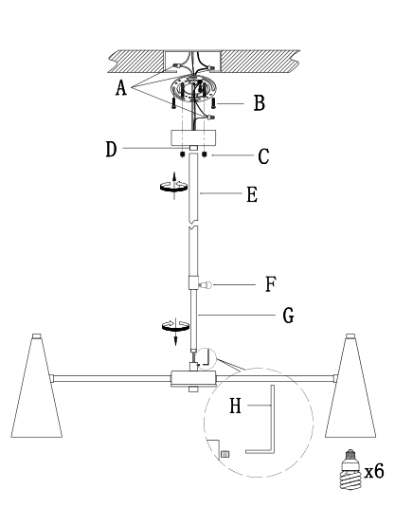

Care instructions:
• Wipe with soft dry cloth only
• Always avoid the use of harsh chemicals or abrasive as they may damage to the finish.
Thank you for your purchase

