

ASSEMBLY INSTRUCTIONS
Serenitie Chandelier (Item# II150-0149)
Caution:
- FOR YOUR SAFETY: Turn off the power to main electric circuit/ fuse box before beginning work.

Important Safety Instructions:
- Professional installation is recommended for hardwired lighting. Incorrect installation can lead to fires.
- These instructions are provided for your safety. It is very important that they are read carefully and completely before assembling fixture.
- We strongly recommend that two people install the lighting fixture.
- This fixture has been rated for up to (5) 40-watt maximum TYPE B bulbs (not included) or (5) 9-watt compact fluorescent light bulbs (not included). To avoid the risk of fire, do not exceed the recommended wattage.
- This lighting fixture is intended for indoor, residential use.

Warning:
- To reduce the risk of fire, electrical shock or personal injury, do not turn on lighting fixture until light bulb is installed and assembly is complete.
- Always turn off the lighting fixture and allow it to cool before replacing the light bulb.

Care Instructions:
- Do not polish or use harsh cleaners as they may damage the finish.
- Wipe clean with a non-colored, lint-free soft, dry cloth.

Pre-assembly:
- Remove all parts and hardware from box along with any plastic protective packaging.
- Check that all parts listed are included.
- Do not discard any contents until after assembly is complete to avoid accidentally discarding small parts or hardware.

Component List
Part Code | Components | Description | Qty
A |  | Mounting Plate | 1
B | 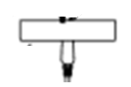 | Canopy with Swivel Head | 1
C | 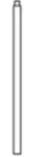 | 12” Long tube | 2
D |  | 6” Shorter tube | 1
E | 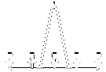 | Body | 1
F | 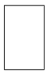 | Shade | 5

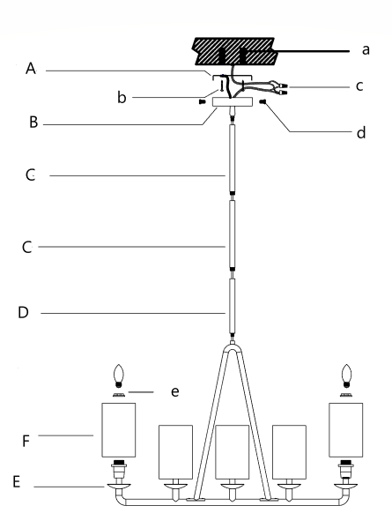

Part code | Components | Description | Qty
a | 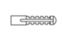 | Plastic Screw Anchor | 3
b | 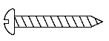 | Point Screw | 3
c | 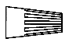 | Wire nut | 3
d | 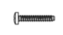 | Grub Screw | 3
e | 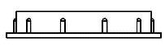 | Socket cap | 5

Assembly Instruction:

Step 1. Unpack and place all parts on a surface or floor.

Step 2. Secure the mounting plate (A) to the ceiling using plastic screw anchors (a) and point screws (b).

Step 3. The fixture comes with two 12-inch long rods (C) and one 6-inch shorter rod (D). Use tubes (C) and (D) to create your desired hanging height and then pass the fixture wires through the selected tubes (C) and (D). Gently screw the tubes (C) and (D) onto the fixture body (E).
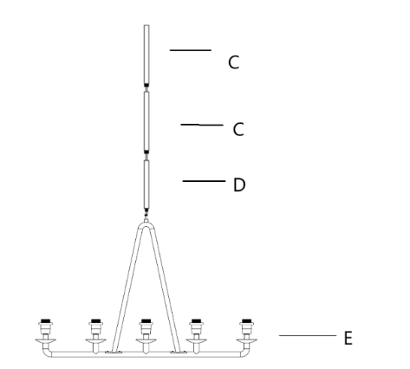
Step 4. Put the canopy (B) on the long tube (C), screw to tight.
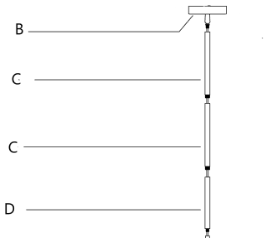

Step 5: Make wire connections. Have another person support the fixture’s weight while completing the wiring. Attach the fixture’s wires to the power supply wires from the junction box. Connect black to black (Live); white to white (grounded); grounding to grounding (green or copper). Twist the ends of the wire pairs together. Then, twist on a wire connector. Make sure all twists are in the same direction. Loop fixture’s ground wire around grounding screw and tighten. If there is no ground wire (green or copper) from the junction box, contact a qualified electrician.

Step 6: With the help of another person to hold the weight of the lighting fixture, raise the canopy (B) to the ceiling and secure it in place by attaching the canopy (B) to the mounting plate (A) using the grub screws (d).
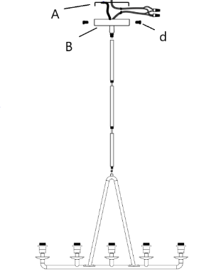

Step 7: Gently put the shade (F) on the socket, and then screw socket cap (e) onto the socket. Finally put the bulbs (not included) into the sockets. (Please do not exceed the maximum wattage recommended on the socket.). Repeat this process for all 5 lights.
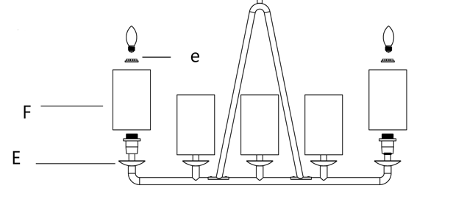

Step 8. Check everything is installed properly, then you can turn on the light. Enjoy!

