
ASSEMBLY INSTRUCTIONS
Ashbourne Resin Table Lamp (Item#FB153-1174)
Important Safety Instructions:
- For safety purpose, this lamp is equipped with a polarized plug (one blade is wider than the other). If the plug does not fit securely into your outlet, do not force it, contact a professional electrician. Never alter the plug in any way.
- These instructions are provided for your safety. It is very important that they are read carefully and completely before assembling fixture.
- This fixture has been rated for up to (1) 60-watt maximum TYPE A bulb or (1) 13-watt compact fluorescent light bulb. To avoid the risk of fire, do not exceed the recommended wattage.
- This lighting fixture is intended for indoor, residential use.

Warning:
- Wires and cables are all attached (further wiring is not needed from consumer). When unpacking product, be careful to not pull wires as it may result in a bad connection. Do not plug into electrical outlet until lamp is fully assembled.
- To reduce the risk of fire, electrical shock or personal injury, do not turn on light fixture until light bulb is installed and assembly is complete.
- Always turn off the light fixture and allow it to cool before replacing the light bulb.

- Care instructions:
- Wipe with soft dry cloth only
- Always avoid the use of harsh chemicals or abrasives as they may damage

Page 1 of 2

Pre-assembly:
- Remove all parts and hardware from box along with any plastic protective packaging.
- Check that all parts listed are included.
- Do not discard any contents until after assembly is complete to avoid accidentally discarding small parts or hardware.

Component List
Part Code | Component | Description | Qty
A |  | Finial | 1
B | 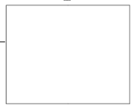 | Shade | 1
C | 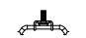 | Harp top | 1
D | 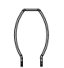 | Harp | 1
E |  | Harp caps | 1
F&G | 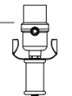 | Socket and Saddle | 1
H | 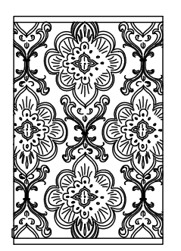 | Body | 1
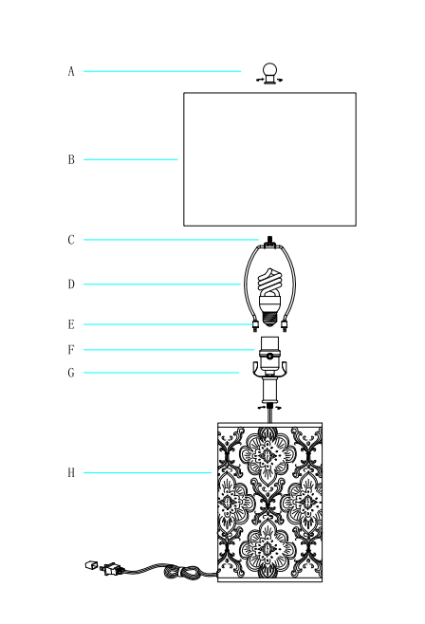

Assembly Instruction:

Step1. Unpack and place all parts on a surface or floor.

Step2. Put the lamp body (H)on the table, gently pull the cord so that the neck comes into contact with the body (H).

Screw the socket (F) and saddle(G) onto the lamp body (H).
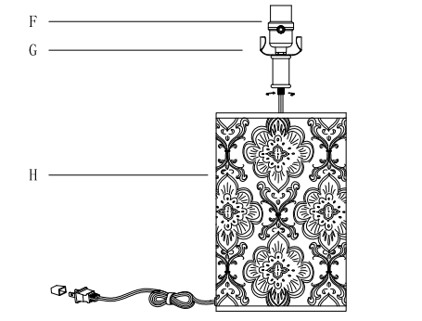
Step 3. Raise the harp caps (E) and insert the bottom ends of harp (D) into the saddle (G.)
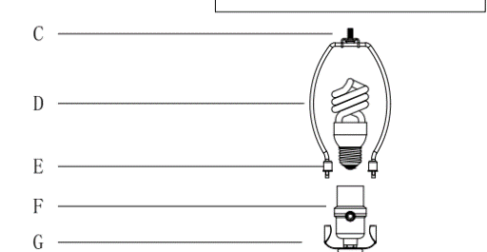
Step 4. Lower the harp caps (E) until they cover the two-pronged saddle (G)
Step 5. Place the shade (B) over the harp (D) making sure the harp top (C) extends through the top ring of shade (B). Secure the shade (B) by turning the finial (A) onto the harp top (C) clockwise until tight.
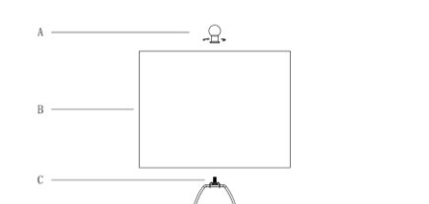

Step6. Screw the light bulb into the socket (F).
Step7. Assembly is completed.

