ASSEMBLY INSTRUCTIONS
Torci Floor lamp (Item#: OV154-0003/OV154-0004)

Important Safety Instructions:
- These products are only suitable for connection to a 120V~60Hz supply in accordance with current IEE wiring Regulations and should be installed in accordance with local Building Regulations and are for indoor use only,They are not suitable for a Bathroom location
- Do not plug into the mains until your lamp is fully assembled
- These instructions are provided for your safety. It is very important that they are read carefully and completely before assembling fixture.
- This lamp contains non-replaceable LED. Do not stare into the LED beam.DC,20W

Pre-assembly:
- Do not discard any contents until after assembly is complete to avoid accidentally discarding small parts or hardware.
- Remove all parts and hardware from box along with any plastic protective packaging.

Parts Enclosed:

Item | Description | QTY
A | shade | 1
B | tube | 1
C | tube | 1
D | tube | 1
E | base | 1
F | connector | 1
G | Driver connector | 1

Warning:
- Wires and cables are all attached (further wiring is not needed from consumer). When unpacking product, be careful to not pull wires as it may result as a bad connection. Do not plug into electrical outlet until lamp is fully assembled.

Assembly Instruction:

Step1. Unpack and place all parts on a surface or floor.

Step2. Attach tube (D) into the base (E),attach tube (C) into tube (D),then attach the
tube (B) into tube (C) until tight
Step3. Fully insert the driver connector (G) into the connector (F) and secure this joint by tightening.
Step4 .Assembly is completed.

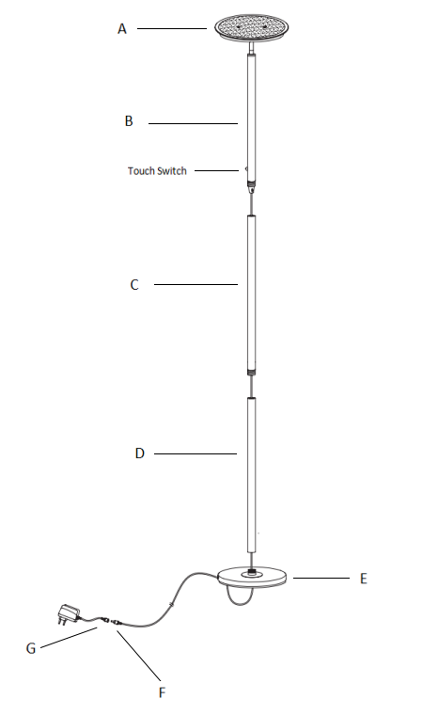
Care instructions:
• Wipe with soft dry cloth only
• Always avoid the use of harsh chemicals or abrasive as they may damage to the finish.

Thank you for your purchase

