 ASSEMBLY INSTRUCTIONS

Capital Task Lamp (Item# 5DS153-0002)
Important Safety Instructions:
- For safety purpose, this lamp is equipped with a polarized plug (one blade is wider than the other). If the plug does not fit securely into your outlet, do not force it, contact a professional electrician. Never alter the plug in any way.
- These instructions are provided for your safety. It is very important that they are read carefully and completely before assembling fixture.
- This fixture has been rated for up to (1) 60-watt maximum TYPE A bulb or (1) 13-watt compact fluorescent light bulb. To avoid the risk of fire, do not exceed the recommended wattage.

Pre-assembly:
- Do not discard any contents until after assembly is complete to avoid accidentally discarding small parts or hardware.
- Remove all parts and hardware from box along with any plastic protective packaging.
Parts Enclosed:
Item | Description | QTY
A | Lamp base | 1
B | Straight pipe | 1
C | Lamp body | 1
D | Shade | 1
E | Socket | 1
F | Lamp knob | 1

Warning:
- Wires and cables are all attached (further wiring is not needed from consumer). When unpacking product, be careful to not pull wires as it may result as a bad connection. Do not plug into electrical outlet until lamp is fully assembled.

Note:

Turn the power off (unplug from the wall outlet) before replacing the bulb. Make sure the bulb has sufficient time to cool down.

Assembly Instruction:

Step 1: Open the package and place all the components on the surface or on the floor.

Step 2: Put the lamp base (A) on the table.

Step 3: Raise the straight pipe (B), and insert the lamp base (A).

Step 4: Raise the lamp body (C), and insert the straight pipe (B).

Step 5:. .Place the shade (D) and making sure the socket (E) extends through the round hole of shade (D)

. Secure the shade (D) by turning the lamp knob (F) onto the socket (E) clockwise until tight

Step 6: Screw the light bulb into the socket (E).

Step 7: Assembly is completed.
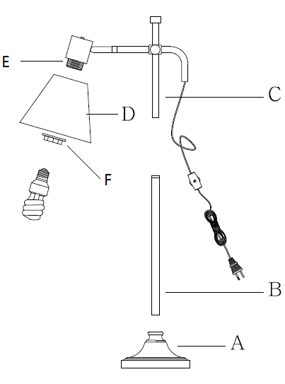

Care instructions:
• Wipe with soft dry cloth only
• Always avoid the use of harsh chemicals or abrasive as they may damage to the finish.
Thank you for your purchase

